# 

# Submitted By:

# 

|  |  |  |
| --- | --- | --- |
| **Name** | **ID** | **Contribution** |
| NUSHRAT JAHAN | **22-46149-1** |  |
| TRIDIB SARKAR | **22-46444-1** |  |
| S.M. MUJAHID SOUROV | **22-49679-3** |  |
| MD. ATIK ISHRAK SUJON | **22-46684-1** |  |
| MD. FAHIM MURSHED | **22-46695-1** |  |

Date of Submission: , 2023

# TABLE OF CONTENTS

|  |  |
| --- | --- |
| **TOPICS** | **Page no.** |
| 1. **Cover Page** |  |
| **II. Table of Contents** |  |
| **Title** |  |
| **Abstract** |  |
| **Theory & Methodology** |  |
| **Apparatus** |  |
| **Experimental Procedure** |  |
| **Circuit Diagram** |  |
| **Images** |  |
| **IC Configuration** |  |
| **Simulation** |  |
| **Result & Discussion** |  |
| **References** |  |
|  |  |

**Title:**

Construction of Diode and Transistor Logic Gates

**Part I: Construction of Diode Logic Gates**

A digital logic gate is an electronic circuit which makes logical decisions based on the combination of digital signals present on its inputs. A a digital logic gate can have more than one input, for example, inputs A, B, C, D etc. but generally only have one digital output. Individual logic gates can be connected together to from a logic gate function with any desired number of inputs or to from combinational and sequential life circuits or to produce different logic gate functions from Standard gates.

**Introduction:**

A diode is a two-terminal electrical device that allows current to flow in one direction but not the other. It is like a pipe with an internal valve that allows water to flow freely in one direction but shuts down if the water tries to flow in another direction. The diode’s two terminals are called the anode and cathode. In the diode symbol, the arrow points from the anode (the flat part of the triangle) toward the cathode (the point of the triangle).

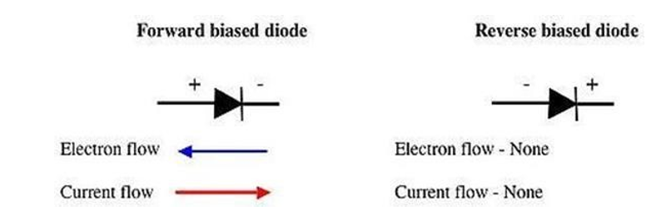

Figure 1: Diode biasing directions

**Theory and Methodology:**

## **Diode Logic OR Gate*:***

A Diode Logic (DL) OR gate consists of nothing more than diodes (one for each input signal) and a resistor. Here, the 10 kΩ resistor (*R*) is added to provide a ground reference for the output signal. If there are no input signals connected to the diodes, the output will be ground, or logic 0. Thus, an open input is equivalent to a logic 0 input and will have no effect on the operation of the rest of the circuit. It is possible to add any number of input diodes to this circuit, each with its separate input signal. However, two inputs are quite sufficient to demonstrate the operation of the circuit.

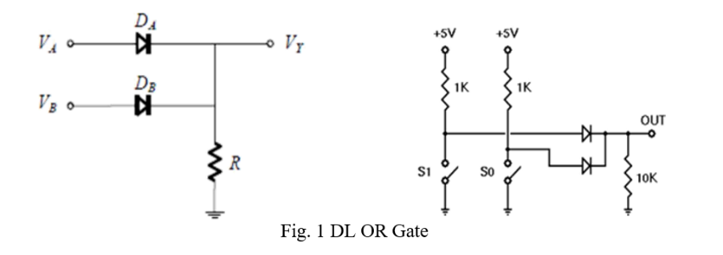

Assuming the diodes are ideal, the voltage-based truth table as given in Table 1 (a) is obtained. The corresponding logic-based or binary truth table is given in Table 1 (b):

Table 1: (a) Voltage-based truth table, (b) Logic-based or binary truth table of DL OR gate

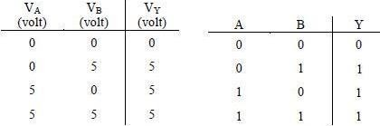

## **Diode Logic AND Gate:**

A Diode Logic AND gate consists of diodes (one for each input signal) and a resistor. As with the DL OR gate, the 10KΩ resistor (R) provides a reference connection. Unlike the OR gate, however, this is a reference to +5 volts, rather than to ground. If there are no input signals connected to the diodes, the output will be +5 volts, or logic 1. Thus, an open input will not affect the rest of the circuit, which will continue to operate normally. As with DL-OR gates, it is possible to add any number of input diodes to this circuit, each with its separate input signal. However, two inputs are quite sufficient to demonstrate the operation of the circuit.

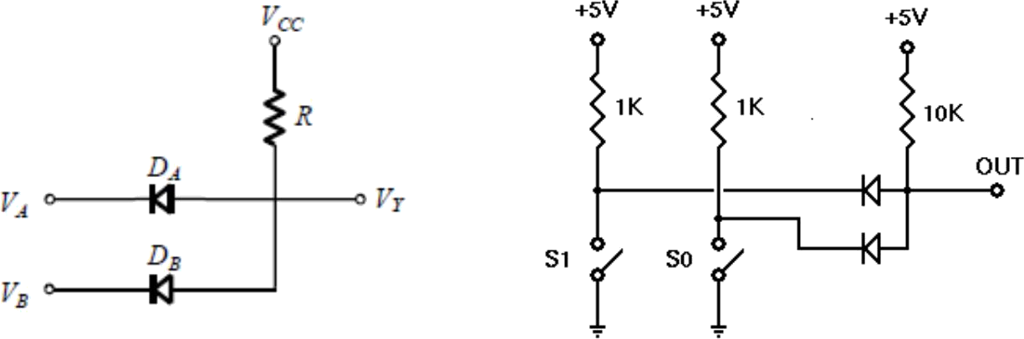

(a)

b)

Fig. 2 DL AND Gate

Assuming the diodes are ideal, the voltage truth table of the above AND gate is as given in Table 2 (a). The corresponding logic truth table is in Table 2(b).

Table 2: (a) Voltage-based truth table, (b) Logic-based or binary truth table of DL AND gate

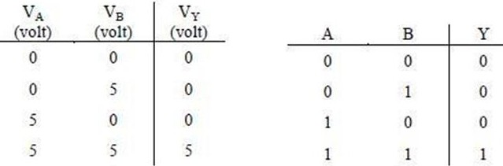

**Apparatus:**

1. 10 kW ohm resistor (Color band: brown-black-orange).
2. 1N914/1N4002 diodes or equivalent.
3. Connecting wires.
4. Trainer Board

**Part 2: Construction of bipolar transistor logic gate:**

**Introduction:**

A bipolar transistor is a three-terminal semiconductor device. Under the control of one of the terminals, called the base, current can flow selectively from the collector terminal to the emitter terminal.

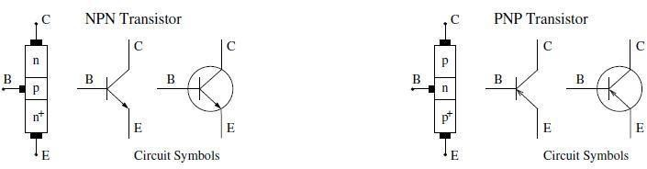

Fig. 3: Bipolar Junction Transistor (BJT) circuit symbols

In this experiment, we examine how to build logic gates from Bipolar Junction Transistors (BJT) using the RTL, DTL, and TTL design.

**Theory and Methodology:**

## **Resistor-Transistor Logic (RTL):**

Resistor-Transistor Logic (RTL) is a large step beyond Diode Logic (DL). Basically, RTL replaces the diode switch with a transistor switch. If a +5 V signal (logic 1) is applied to the base of the transistor (through an appropriate resistor to limit base-emitter forward voltage and current), the transistor turns fully on and grounds the output signal. If the input is grounded (logic 0), the transistor is off and the output signal is allowed to rise to + 5 V. In this way, the transistor not only inverts the logical sense of the signal but also ensures that the output voltage will always be a valid logic level under all circumstances. Because of this, RTL circuits can be cascaded indefinitely, whereas DL circuits cannot be cascaded reliably at all.

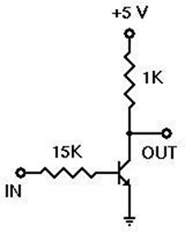

Fig. 4: RTL Inverter

## **Diode-Transistor Logic (DTL):**

Diode-Transistor Logic (DTL) is a class of digital circuits built from Bipolar Junction Transistors (BJT), diodes, and resistors; it is the direct ancestor of Transistor–Transistor Logic (TTL). DTL offers better noise margins and greater fan-outs than RTL but suffers from low speed (especially in comparison to TTL). RTL allows the construction of NOR gates easily, but NAND gates are relatively more difficult to get from RTL. DTL, however, allows the construction of simple NAND gates from a single transistor, with the help of several diodes and resistors.

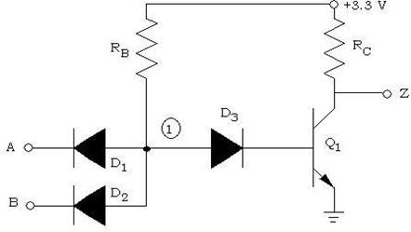

Fig. 5: 2-input DTL NAND Gate

## **Transistor-Transistor Logic:**

We can think of a bipolar transistor as two diodes placed very close together, with the point between the diodes being the transistor base. Thus, we can use transistors in place of diodes to obtain logic gates that can be implemented with transistors and resistors only; this is called Transistor-Transistor Logic (TTL).

One problem that DTL doesn't solve is its low speed, especially when the transistor is being turned off. Turning off a saturated transistor in a DTL gate requires it to first pass through the active region before going into cut-off. Cut-off, however, will not be reached until the stored charge in its base has been removed. The dissipation of the base charge takes time if there is no available path from the base to the ground. This is why some DTL circuits have a base resistor that's tied to the ground, but even this requires some trade-offs. Another problem with turning off the DTL output transistor is the fact that the effective capacitance of the output needs to charge up through *Rc* before the output voltage rises to the final logic '1' level, which also consumes a relatively large amount of time. TTL, however, solves the speed problem of DTL elegantly.

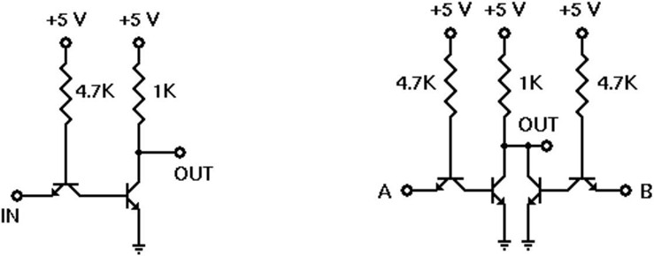

Fig. 6: TTL Inverter Fig. 7: 2-input TTL NOR gate

## **Emitter-Coupled Logic (ECL):**

The operation of Emitter-Coupled Logic (ECL) is that whenever the HIGH input is given to any one of the ECL circuits, it will make the transistors ON. So, this will pull the output, *Vo,* down to LOW.

Similarly, when the LOW input value is given to all the transistors’ input then it will make all the transistors OFF. So, it will make the output, *Vo* be pulled up to the HIGH value because of the drop within 640 W resistance.

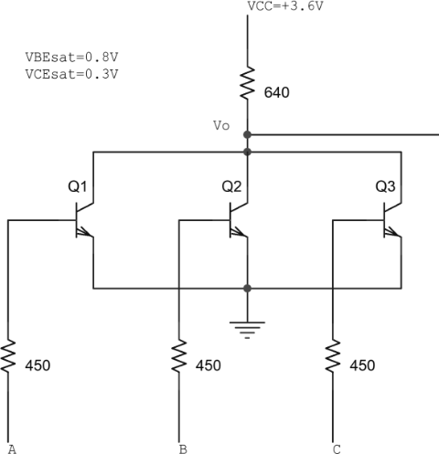

Fig. 8 A 3-input ECL NOR gate

**BJT Pin Configuration:**

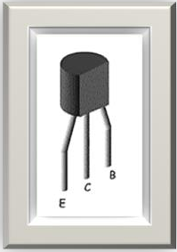

**Apparatus:**

* 1. 2N4124 NPN silicon transistor (or equivalent).
  2. Resistors (15 kΩ, 1 kΩ, 4.7 kΩ)
  3. Connecting wires.
  4. Trainer Board

**Experimental Procedure:**

1. We constructed the DL-OR gate on the breadboard using diodes then we create the truth table.
2. We constructed the DL-AND gate on the breadboard using diodes then we create the truth table.
3. We constructed the DTL-NAND gate on the breadboard using diodes and transistors then we create the truth table.
4. We constructed the TTL-Inverter gate on the breadboard using transistors then we create the truth table.
5. We constructed the RTL-Inverter gate on the breadboard using resistors and transistors then we create the truth table.
6. We constructed the TTL-NOR gate on the breadboard using transistors then we create the truth table.
7. We constructed the ECL-NOR gate on the breadboard using transistors and resistors then we create the truth table.

**Simulations:**

**Circuit Diagram:**

**Result and discussion:**

In this experiment, we implemented some applications of AND, OR, NAND, NOR and Inverter by using diode and transistor. Wo successfully implemented the circuit and do the result perfectly. Here we used the truth table of the circuit for verification. There might be some errors while doing this experiment. There’s also some instrumental error occur. We also did the simulation of the circuits using Multisim software and verified with the experiment result.

**Reference:**

* Thomas L. Floyd, *Digital Fundamentals*, 9th Edition, 2006, Prentice Hall, India.
* Boylestad, Robert L. *Electronic Devices and Circuit Theory*. Pearson Education, India, 2009.